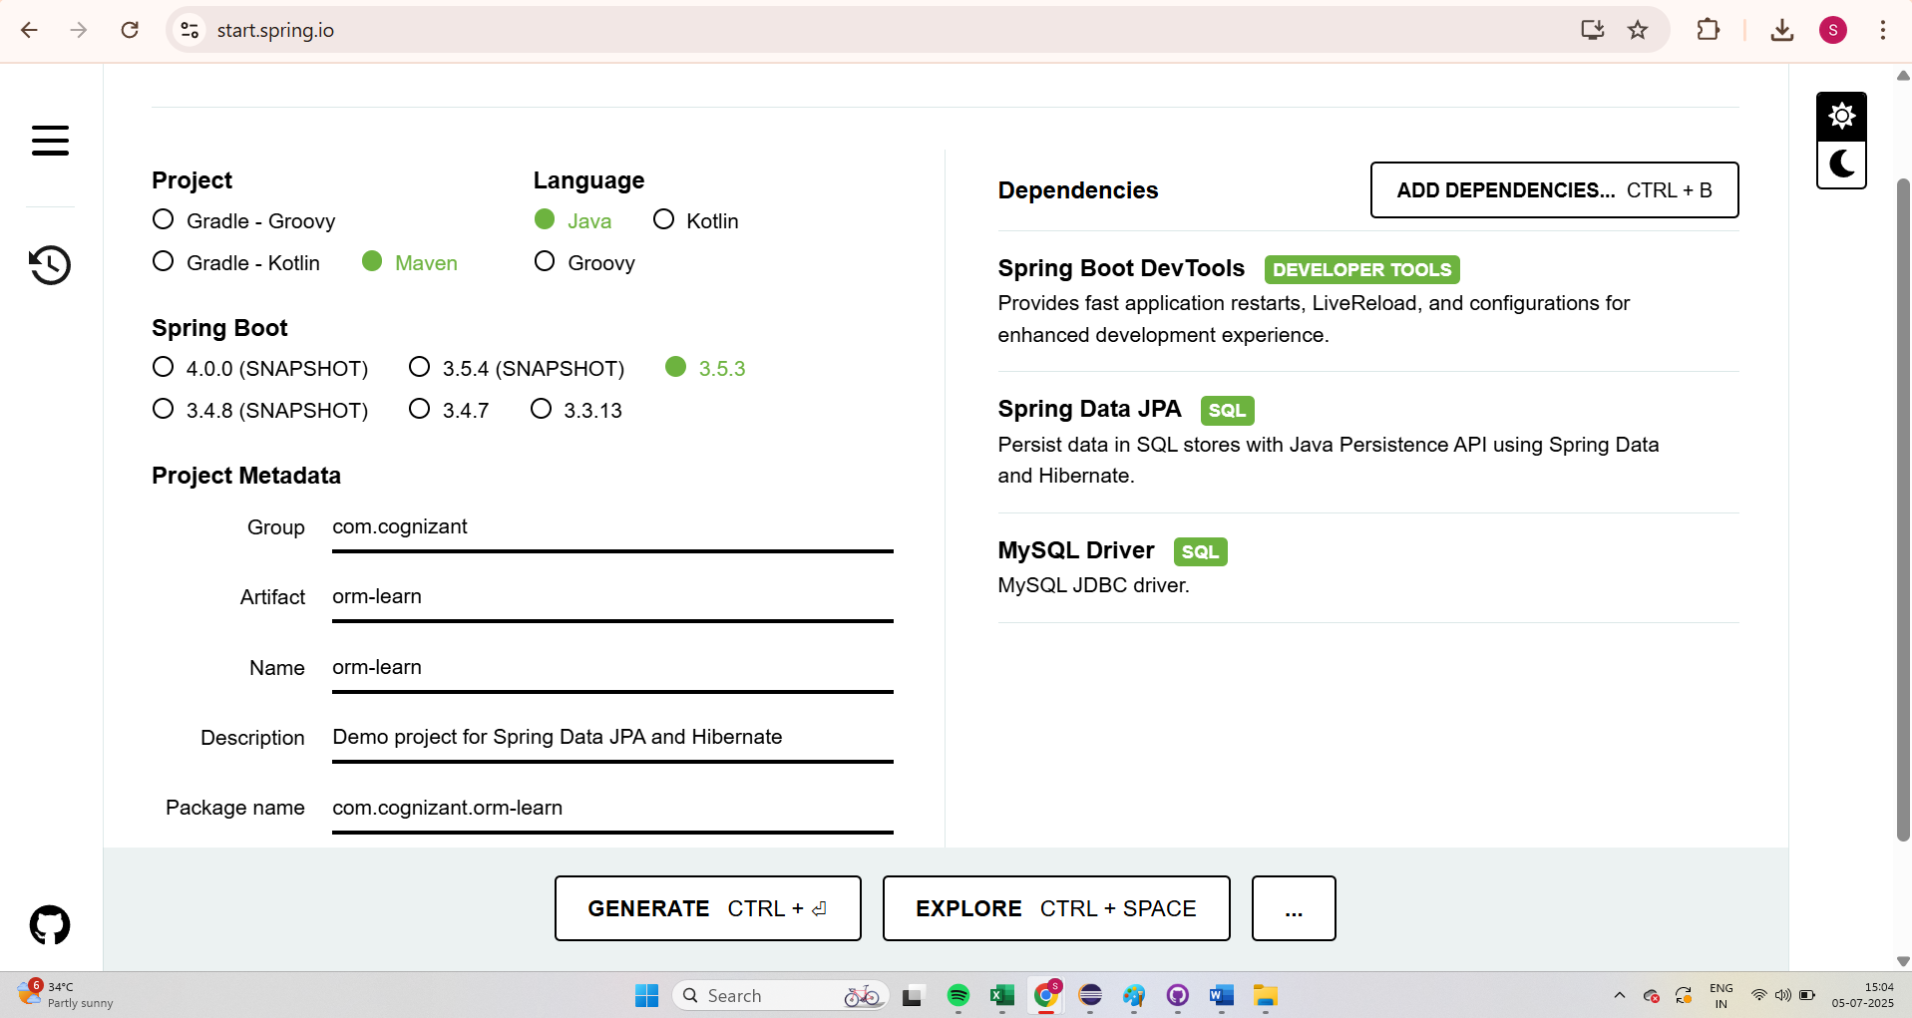

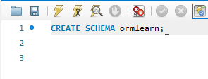

application.properties

# Spring Logging

logging.level.org.springframework=info

logging.level.com.cognizant=debug

# Hibernate SQL logs

logging.level.org.hibernate.SQL=trace

logging.level.org.hibernate.type.descriptor.sql=trace

# Console log pattern

logging.pattern.console=%d{dd-MM-yy} %d{HH:mm:ss.SSS} %-20.20thread %5p %-25.25logger**{25}** %25M %4L %m%n

# DB Configuration

spring.datasource.driver-class-name=com.mysql.cj.jdbc.Driver

spring.datasource.url=jdbc:mysql://localhost:3306/ormlearn

spring.datasource.username=root

spring.datasource.password=root

# Hibernate Config

spring.jpa.hibernate.ddl-auto=validate

spring.jpa.properties.hibernate.dialect=org.hibernate.dialect.MySQLDialect

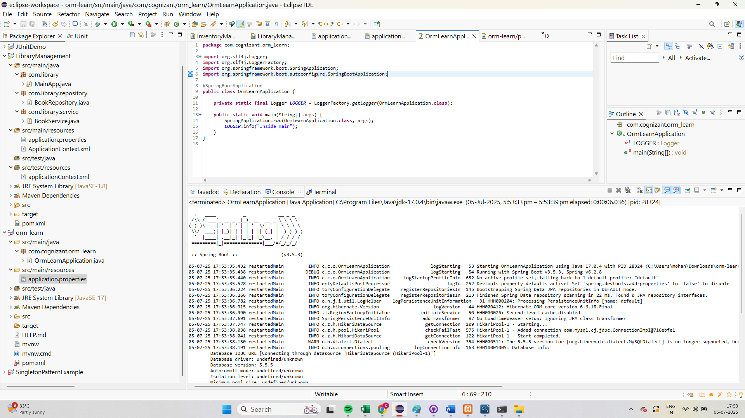

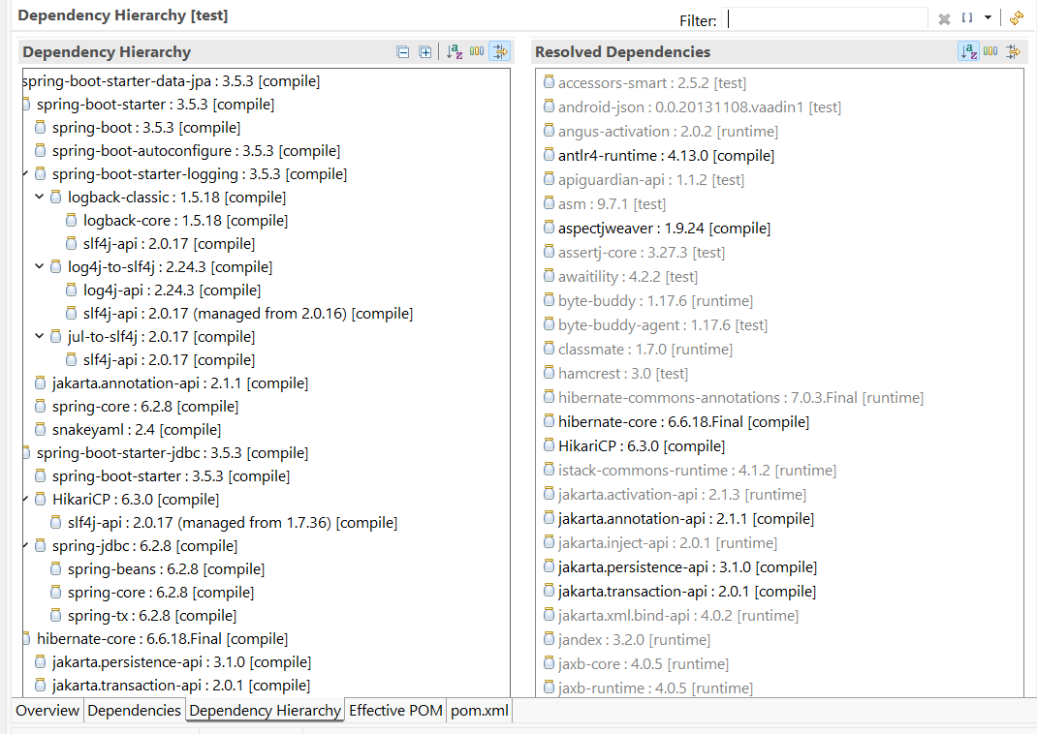

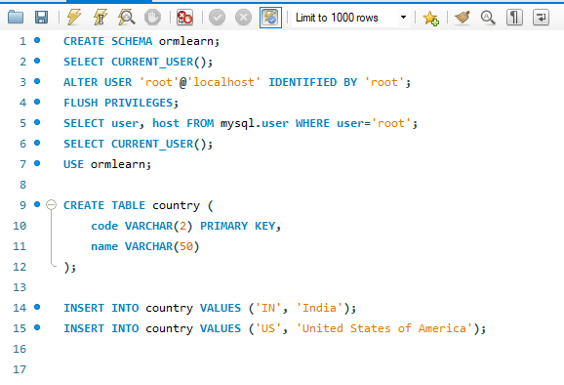

**Country.java**

**package** com.cognizant.ormlearn.model;

**import** jakarta.persistence.*; // Use this if using Spring Boot 3+

@Entity

@Table(name = "country")

**public** **class** Country {

@Id

@Column(name = "code")

**private** String code;

@Column(name = "name")

**private** String name;

// Getters and setters

**public** String getCode() { **return** code; }

**public** **void** setCode(String code) { **this**.code = code; }

**public** String getName() { **return** name; }

**public** **void** setName(String name) { **this**.name = name; }

@Override

**public** String toString() {

**return** "Country [code=" + code + ", name=" + name + "]";

}

}

**OrmLearnApplication.java**

**package** com.cognizant.ormlearn;

**import** com.cognizant.ormlearn.model.Country;

**import** com.cognizant.ormlearn.service.CountryService;

**import** org.slf4j.Logger;

**import** org.slf4j.LoggerFactory;

**import** org.springframework.boot.SpringApplication;

**import** org.springframework.boot.autoconfigure.SpringBootApplication;

**import** org.springframework.context.ApplicationContext;

**import** java.util.List;

@SpringBootApplication

**public** **class** OrmLearnApplication {

**private** **static** **final** Logger ***LOGGER*** = LoggerFactory.*getLogger*(OrmLearnApplication.**class**);

**private** **static** CountryService *countryService*;

**public** **static** **void** main(String[] args) {

ApplicationContext context = SpringApplication.*run*(OrmLearnApplication.**class**, args);

*countryService* = context.getBean(CountryService.**class**);

*testGetAllCountries*();

}

**private** **static** **void** testGetAllCountries() {

***LOGGER***.info("Start");

List<Country> countries = *countryService*.getAllCountries();

***LOGGER***.debug("countries={}", countries);

***LOGGER***.info("End");

}

}

**CountryRepository.java**

**package** com.cognizant.ormlearn.repository;

**import** org.springframework.data.jpa.repository.JpaRepository;

**import** org.springframework.stereotype.Repository;

**import** com.cognizant.ormlearn.model.Country;

@Repository

**public** **interface** CountryRepository **extends** JpaRepository<Country, String> {}

**CountryService.java**

**package** com.cognizant.ormlearn.service;

**import** com.cognizant.ormlearn.model.Country;

**import** com.cognizant.ormlearn.repository.CountryRepository;

**import** org.springframework.beans.factory.annotation.Autowired;

**import** org.springframework.stereotype.Service;

**import** org.springframework.transaction.annotation.Transactional;

**import** java.util.List;

@Service

**public** **class** CountryService {

@Autowired

**private** CountryRepository countryRepository;

@Transactional

**public** List<Country> getAllCountries() {

**return** countryRepository.findAll();

}

}

